Practical lecture 2

Racial inequality
In this exercise, you are asked to investigate some possible origins of wage inequality between white and black men in the US in the early 1990s. The data for this exercise can be found in DataPractical2.xlsx on Moodle. It is a subsample of the National Longitudinal Survey of Youth 1979, a major longitudinal survey which has followed thousands of men and women born in the US between 1954 and 1962 since 1979. The dataset contains the following variables for white and black men:
_ lwage: log wages in 1990
_ race: race of the individuals, either white or black
_ edu: highest grade completed
_ exp: years of experience
_ test: an achievement test score measuring verbal and math ability at the beginning of the survey (1979). The variable reports the individual’s percentile score.
Result below are print(df.head()) (Only the first 5 rows)
- Generate a dummy variable black that takes the value 1 if the individual is black and 0 if he is white.
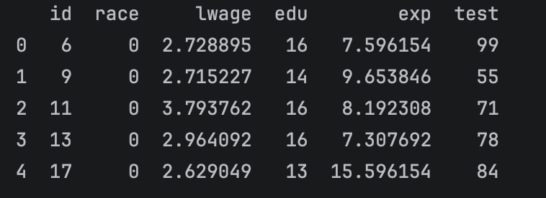
- Regress log wage (lwage) on black. Why can we interpret the coefficient on black as the average gap in wages between whites and blacks in the sample? Why do we need to be careful about interpreting this result as evidence of racial discrimination?
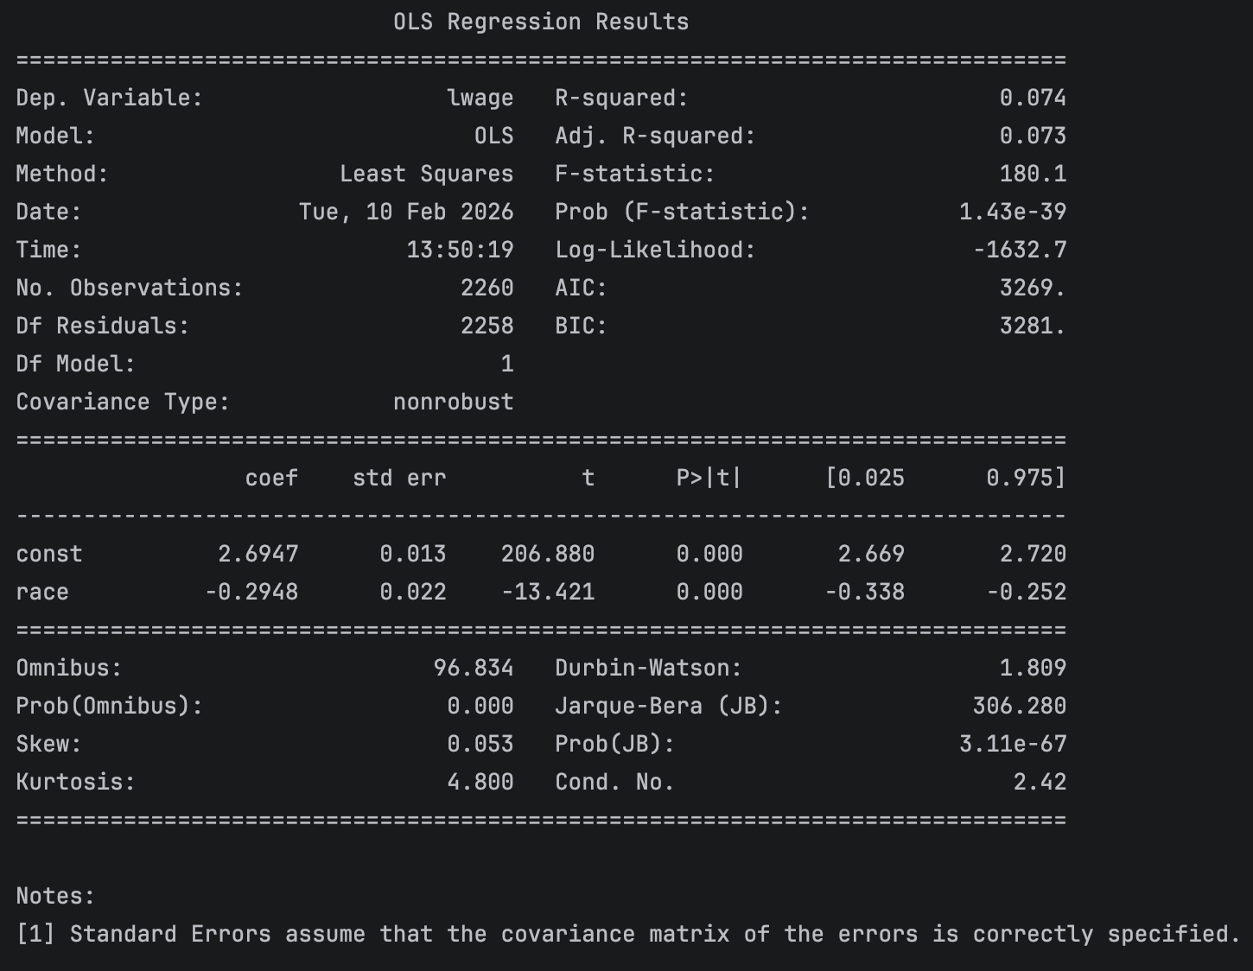
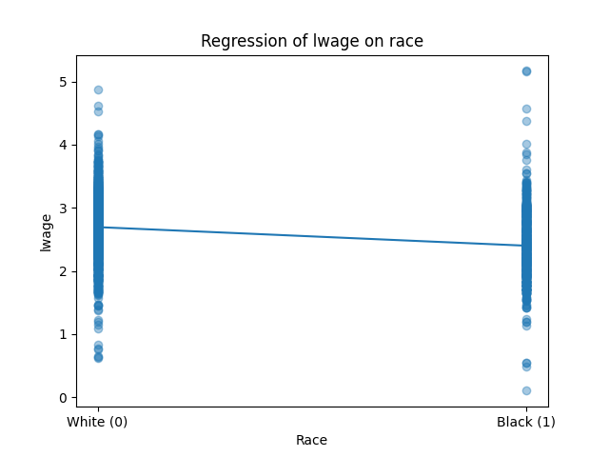
Log Wage = 2.69 – 0.2948Black + u
The coefficient means for every 1 unit increase in race there is 29.5% decrease in wage. It can be interpreted as black peoples’ wage is 29.5% lower than whites. Because there are other variables such as education and experience that directly affect wages. This regression omits these 2 variables. There is a possibility that black people earned less because they have lower working experience and not exactly because of their skin color.

- Regress log wage (lwage) on black, edu and exp. What happens to the coefficient on black? How do you interpret this change?
Log Wage = 1.03 – 0.176Black + 0.0971Edu + 0.0410 Exp
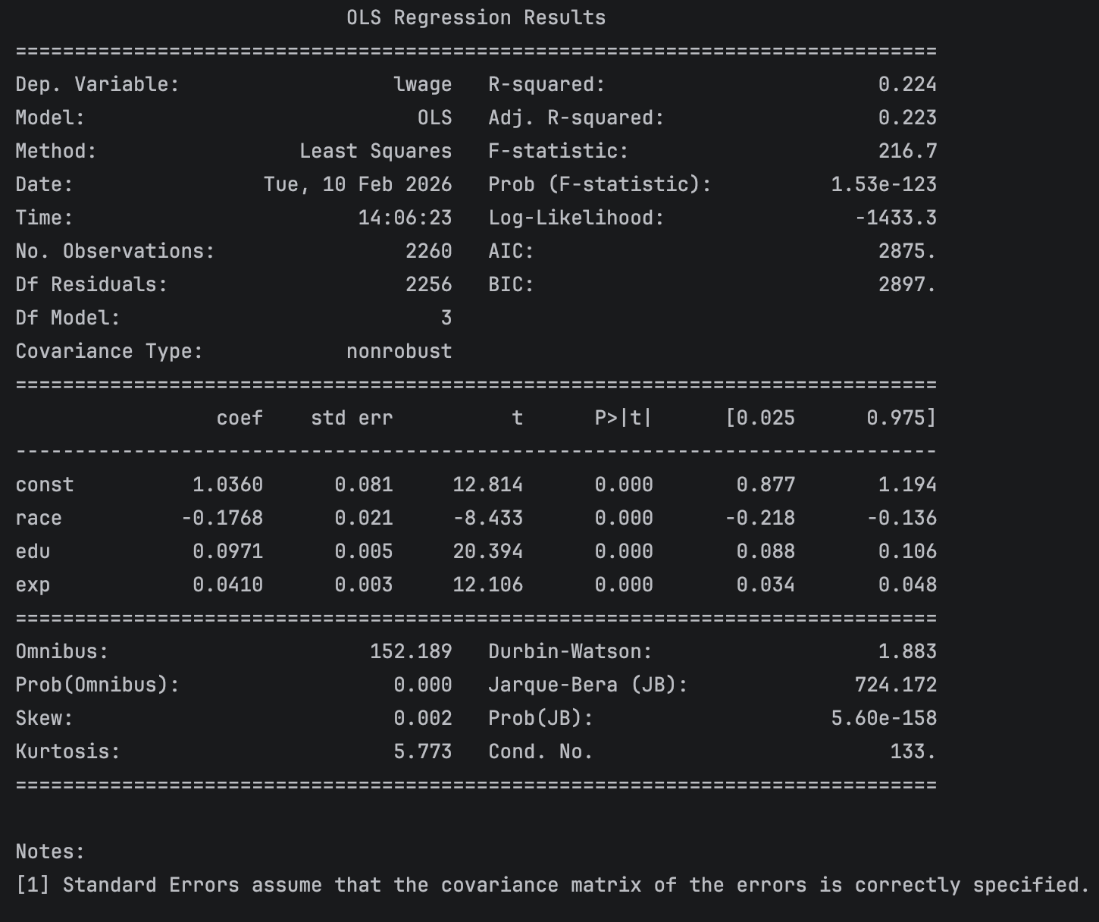

The coefficient on Black decreases, it means that it previously overestimated the effect of race on Wage. The new regression proves that Edu and Exp are important variables to compare the differences of wage between skin color.

- Test whether the returns to experience and education statistically differ between white and black men in the survey.
LogWage = 1.828 – 0.755Race +
Return on education for Black is lower than White. It is statistically significant as the t values is < 1.69 at 0.010.
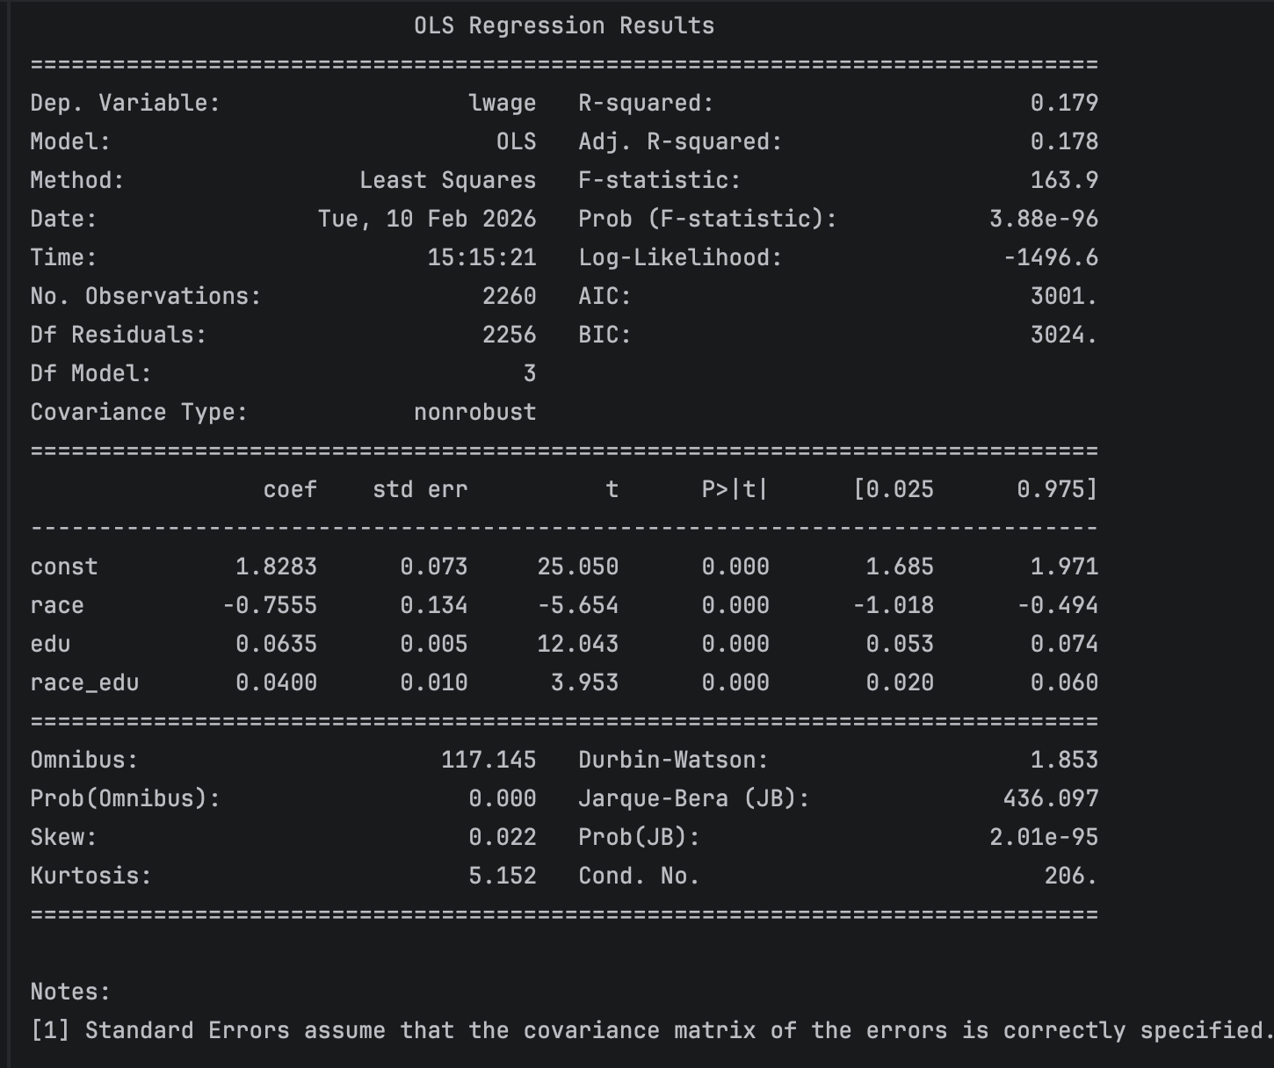

- Add the test score to the regression you estimated in (b). How do you interpret the coefficient on test? What happens to the coefficient on black? By how much is the whiteblack gap in log wages explained by black-white differences in education, experience and test score?

